You're invited!

Join us during this special Holiday Season to see how Nikken can deliver to your family the gift of

Health, Wealth & Freedom

There will be live events all over the continent to celebrate as this iconic company embarks into its' new era!

We are seeking positive, enthusiastic and ambitious people who are passionate about healthy living and want to earn a great income from home by helping other people achieve better and more balanced lives.

Maybe this is the day you can see your dreams finally having the opportunity to come true…

Live Event Location:
Time to Mingle & See how to get a lot of Jingle!

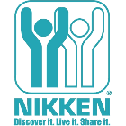 | Date:  12.1.18  Time:  Location:  Contact Info:

